**Project Title**

Prepared by

1. VISHODHAN KRISHNAN , 117A3061

2. THEVAR SARAVANA KUMAR , 117A3059

3.ROHITH RAGHAVAN , 117A3046

4.MARIMUTHU KONAR , 117A3022

Under the Guidance of:

Prof. SEEMA REDEKAR



Department of Information Technology

SIES Graduate School of Technology

2017-2018

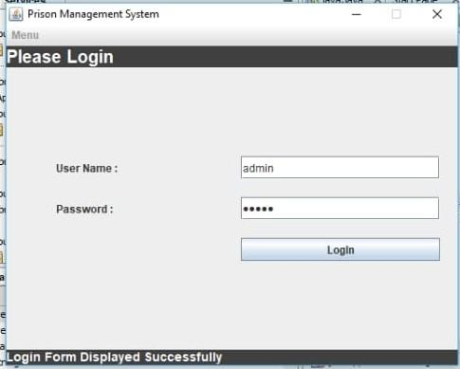

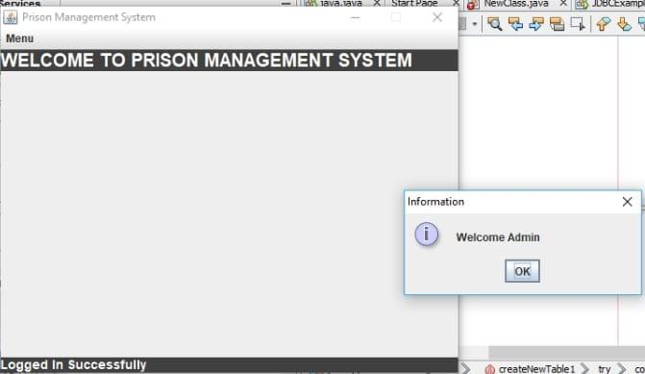

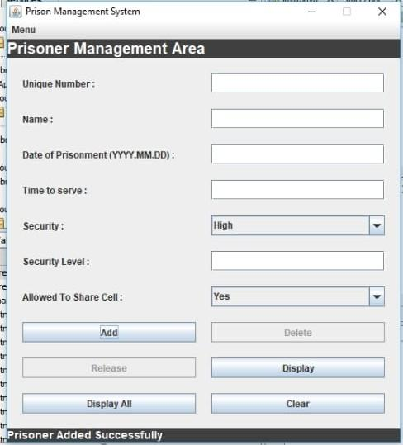

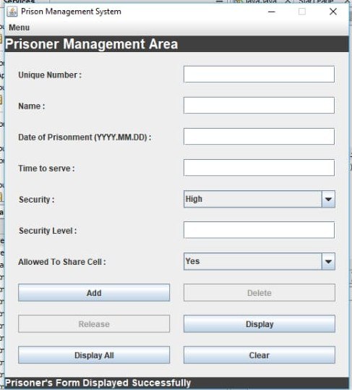

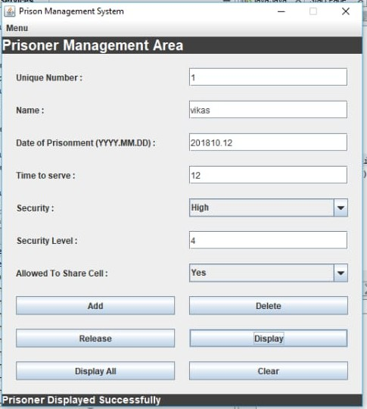

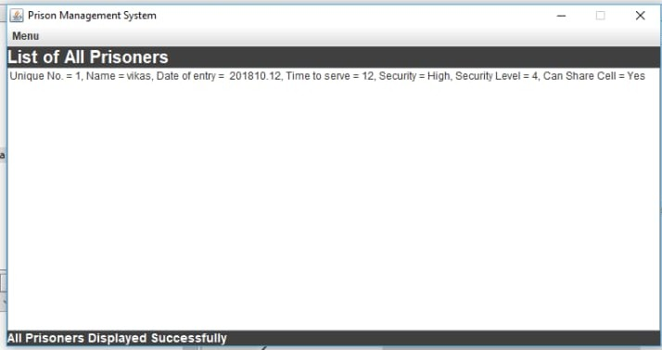

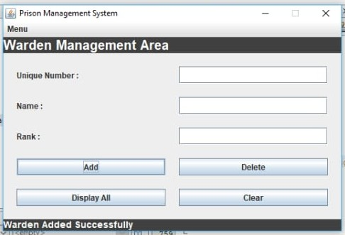

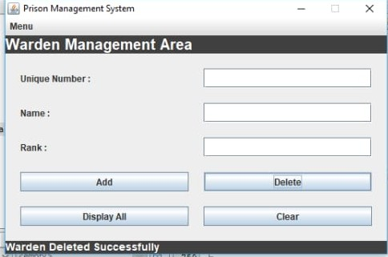

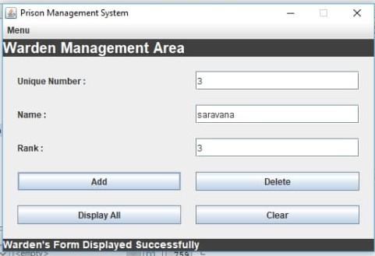

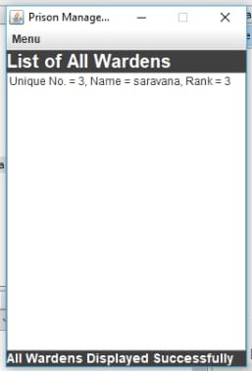

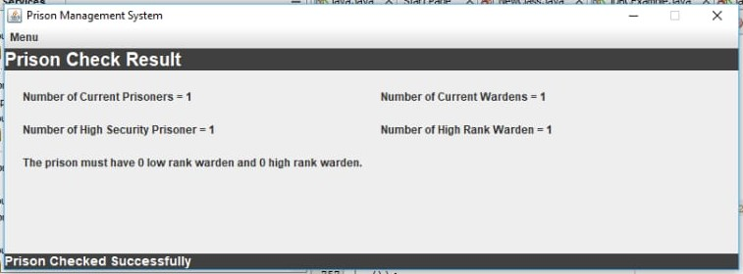

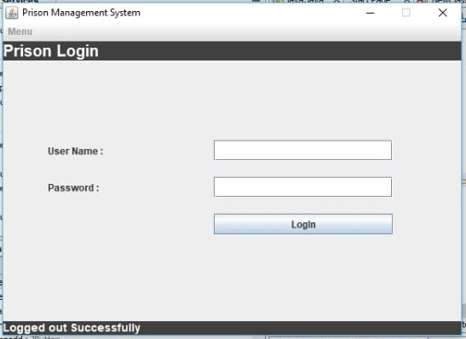

SOFTWARE USED:

NETBEANS 8.2 IDE

PGADMIN 3

public void actionPerformed(ActionEvent e)

{

if (e.getSource() == menuprisoner)

{

/*

* Action performed when prisoner menu chosen

*/

getContentPane().add(pnlPrisoner, BorderLayout.CENTER);

pnlWarden.setVisible(false);

pnlpdspall.setVisible(false);

pnlwdspall.setVisible(false);

pnlCheck.setVisible(false);

//setting prisoner panel visible

pnlPrisoner.setVisible(true);

lblhead.setText("Prisoner Management Area");

lblfoot.setText("Prisoner's Form Displayed Successfully");

pack();

clear();

//clearing list boxes

lstp.clear();

lstw.clear();

}

else if (e.getSource() == menuwarden)

{

//displaying warden panel

getContentPane().add(pnlWarden, BorderLayout.CENTER);

pnlPrisoner.setVisible(false);

pnlwdspall.setVisible(false);

pnlpdspall.setVisible(false);

pnlCheck.setVisible(false);

pnlWarden.setVisible(true);

lblhead.setText("Warden Management Area");

lblfoot.setText("Warden's Form Displayed Successfully");

pack();

//clearing all fields

clear();

lstp.clear();

lstw.clear();

}

else if (e.getSource() == menucheck)

{

//declaring array to be used to store prisoner warden counting

int[] count=new int[4];

try{

public void actionPerformed(ActionEvent e)

{

if (e.getSource() == menuprisoner)

{

/*

* Action performed when prisoner menu chosen

*/

getContentPane().add(pnlPrisoner, BorderLayout.CENTER);

pnlWarden.setVisible(false);

pnlpdspall.setVisible(false);

pnlwdspall.setVisible(false);

pnlCheck.setVisible(false);

//setting prisoner panel visible

pnlPrisoner.setVisible(true);

lblhead.setText("Prisoner Management Area");

lblfoot.setText("Prisoner's Form Displayed Successfully");

pack();

clear();

//clearing list boxes

lstp.clear();

lstw.clear();

}

else if (e.getSource() == menuwarden)

{

//displaying warden panel

getContentPane().add(pnlWarden, BorderLayout.CENTER);

pnlPrisoner.setVisible(false);

pnlwdspall.setVisible(false);

pnlpdspall.setVisible(false);

pnlCheck.setVisible(false);

pnlWarden.setVisible(true);

lblhead.setText("Warden Management Area");

lblfoot.setText("Warden's Form Displayed Successfully");

pack();

//clearing all fields

clear();

lstp.clear();

lstw.clear();

}

else if (e.getSource() == menucheck)

{

//declaring array to be used to store prisoner warden counting

int[] count=new int[4];

try{

Connection connect=DriverManager.getConnection("jdbc:postgresql://localhost:5432/postgres", "postgres", "123456");

Statement state=connect.createStatement();

//sql statement to check all prisoners that are in prison

String sql="select * from prisoner where pstatus='inprison'";

ResultSet rs=state.executeQuery(sql);

while(rs.next())

{

//total prisoners

count[0]=count[0]+1;

if(rs.getString(5).equals("High"))

//high security prisoners

count[1]=count[1]+1;

}

rs.close();

state.close();

}

catch (Exception ex) {

lblfoot.setText(ex+"");

}

try{

Connection connect=DriverManager.getConnection("jdbc:postgresql://localhost:5432/postgres", "postgres", "123456");

Statement state=connect.createStatement();

String sql="select * from warden where wstatus='working'";

ResultSet rs=state.executeQuery(sql);

while(rs.next())

{

count[2]=count[2]+1;

//total wardens

if(rs.getInt(3)>=3)

//high rank wardens

count[3]=count[3]+1;

}

rs.close();

state.close();

}

Connection connect=DriverManager.getConnection("jdbc:postgresql://localhost:5432/postgres", "postgres", "123456");

Statement state=connect.createStatement();

//sql statement to check all prisoners that are in prison

String sql="select * from prisoner where pstatus='inprison'";

ResultSet rs=state.executeQuery(sql);

while(rs.next())

{

//total prisoners

count[0]=count[0]+1;

if(rs.getString(5).equals("High"))

//high security prisoners

count[1]=count[1]+1;

}

rs.close();

state.close();

}

catch (Exception ex) {

lblfoot.setText(ex+"");

}

try{

Connection connect=DriverManager.getConnection("jdbc:postgresql://localhost:5432/postgres", "postgres", "123456");

Statement state=connect.createStatement();

String sql="select * from warden where wstatus='working'";

ResultSet rs=state.executeQuery(sql);

while(rs.next())

{

count[2]=count[2]+1;

//total wardens

if(rs.getInt(3)>=3)

//high rank wardens

count[3]=count[3]+1;

}

rs.close();

state.close();

}